Havant Rugby Club with Sporting Wines Club – Take Away* Wine List
*not for consumption on the premises
Wine | Category | Tasting Notes | Food Paring | Price | HRFC Members Price | Producer | Sport | Country
Red Wines
L10 Malbec  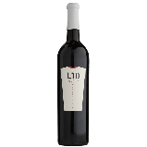 | Red | Bold, Plum and Blackberry  The younger brother of the two L10 Malbecs, this wine is fruitier and more approachable. On the nose this wine has aromas of raspberry and plums with subtle hints of vanilla. A classic Malbec this bottle is dominated by the flavours of ripe plums, cherries, and blackberries. | A rare steak! | £14.00 | £12.60 | Lionel Messi | Football | Argentina
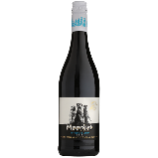  Meerkat Merlot/Cabernet Sauvignon blend | Red | Blackberry Smooth and Brambley  A gregarious and fun blend of Merlot and Cabernet Sauvignon give this wine a ripe red fruit character with tones of sweet blackcurrant and liquorice. It is rounded off with a nutty chocolatiness leaving a long, velvety finish. A wine that punches well above its weight. | The boldness of this blend beautifully compliments most cheese dishes as well as bringing out the flavour of seared and roasted red meats. | £10.95 | £9.86 | Schalk Burger & Sons | Rugby | South  Africa
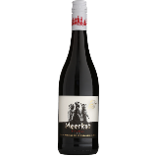  Meerkat Pinotage | Red | Blackcurrant, Plummy and Smokey  A rich, unctuous Pinotage brimming with sweet plum and black cherry characteristics, supported by sensuous mocha chocolate and soft vanilla. | The grapes cinsault heritage lends it compatibility with an assortment of Mediterranean dishes. | £10.95 | £9.86 | Schalk Burger & Sons | Rugby | South  Africa
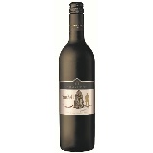  Sumaridge Bushell | Red | Versatile, Soft and Juicy  Merlot, Malbec and Cabernet Franc skilfully brought together in a harmonious blend of dark fruit flavours. A versatile food wine, it is full-bodied with soft tannins and a long finish. | One of the most versatile Sporting Wines. This will match with most roast or seared meat, rich tomato-based pasta or robust fish dishes. | £12.95 | £11.66 | Sumaridge Estate | Rugby | South  Africa
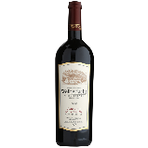  Welbedacht Cabernet Sauvignon | Red | Rich, Leathery and Tannic  A complex nose full-to-bursting with ripe juicy plums, blackcurrant and sweet liquorice, supported by cloves, coconut and black pepper. On the palate, it’s a jammy blend of fruits and spice with vanilla-softened tannins and a lasting finish. | Juicy Cabernet Sauvignon must be enjoyed with rich red meat dishes. | £14.95 | £13.45 | Schalk Burger & Sons | Rugby | South  Africa
Peregrine Pinot Noir  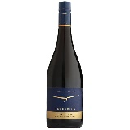 | Red | Red Cherry and Spice  Silky and elegant with dark red cherry, spice and blackcurrant. This wine combines purity and elegance with texture, concentration, and length. | This wine is ideally paired with roast pork with herbs & fennel, Duck, Venison or a Rack of lamb served pink. | £25.95 | £23.35 | Peregrine Winery | Rugby | New Zealand
Rose & Sparkling Wines
Tara  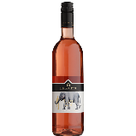 | Rose | Salmon-Pink and Fruity  This Rosé shows a brilliant carmine colour and a fresh bouquet of strawberry and red forest fruit. A carefully crafted wine using early-harvested Merlot, Cabernet Franc and Malbec grapes that is both elegant and classy on a warm summer’s day. | This soft, easy drinking but flavourful wine is ideally served chilled with alfresco fare or simply enjoyed on its own. | £13.95 | £12.55 | Sumaridge Estate | Rugby | South  Africa
Prosecco Brut DOC  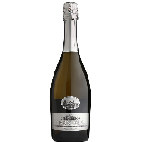 | Sparkling | Light, Bubbly & Fresh  This elegant Prosecco from the Collalbrigo estate has notes of crisp apple and pear with underlying citrus tones. It’s well rounded with fine bubbles that tickle your nose and has a refined, refreshing finish. Adds the perfect sparkle to any occasion. | Excellent as an aperitif, paired with light and crisp salad or vegetable based dishes, and especially good with fresh seafood. | £15.95 | £14.35 | Collalbrigo Estate | Rugby | Italy
Mon René  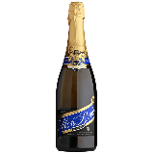 | Sparkling | Pineapple, Dry and Creamy  A refined Cap Classique sparkler with crisp citrus and pineapple notes. It has a persistent mousse with a creamy and richly textured finish. It is fresh and elegant, perfect for a celebration or as an aperitif. | Fish and chips or seafood nibbles. | £14.95 | £13.45 | Schalk Burger & Sons | Rugby | South  Africa
White Wines
L10 Torrontes  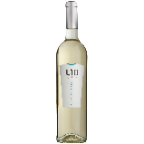 | White | White Peach, Aromatic and Floral  An aromatic varietal indigenous to Argentina, the Torrontes grape produces fresh, aromatic wines with moderate acidity and distinctive floral and apricot aromas – this one is no different! Dry and crisp with lively citrus and white peach flavours. It is best consumed young and fresh so why wait! | Pair with all light-medium chicken dishes. Salmon Ceviche! Salmon is in many ways the chicken of the fish world and pairs superbly. | £14.00 | £12.60 | Lionel Messi | Football | Argentina
Sumaridge Klip Kop  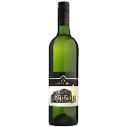 | White | Sauvignon Blanc and Semillon combine to offer a refreshing and crisp blend with balanced minerality. The ripeness of the vintage is evident as the flavours of fresh green fruits give way to tropical notes. | Savoury and dessert dishes, enhancing both rich meaty sauces as well as indulgent chocolate desserts. | £11.95 | £10.75 | Schalk Burger & Sons | Rugby | South  Africa
Meerkat Chenin Blanc  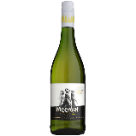 | White | Aromatic, citrussy and dry  A delightful fusion of white fruits, lychee, apple and quince, with a rich tropical aroma. A gold medal-winning Chenin with a fresh and fruity palate and a long finish. | The robust flavours of this wine match superbly with stronger flavoured foods particularly dairy dishes. Try with toasted goats cheese or a good old-fashioned ploughman’s with chutney. | £10.95 | £9.85 | Schalk Burger & Sons | Rugby | South  Africa
Collalbrigo Pinot Grigio  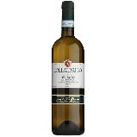 | White | Citrussy & Gentle with soft Pear  This pale yellow wine is a fabulously surprising Pinot Grigio. It has an understated nose that positively bursts on the palate with both tropical and citrus fruits and hints of pear drops. This, combined with a great body and softness, makes the wine versatile with or without food. | This delicate yet fruit-driven wine pairs brilliantly with aromatic seafood dishes or a fruity salad. An aromatic Asian seafood salad fits the bill perfectly! | £14.95 | £13.45 | Collalbrigo Estate | Rugby | Italy

The Sporting wines – the Winemakers

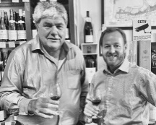
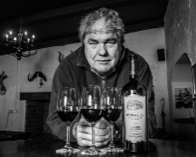
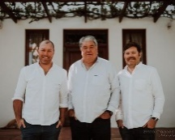
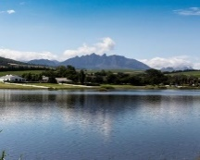
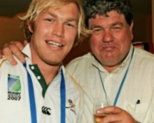
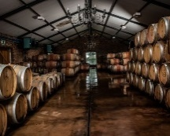
SCHALK BURGER & SONS

We first met Schalk Burger Senior in 2009 from an introduction by Allan Lamb the Test cricketer. As the owner of the Welbedacht Wine Estate we soon realised that here was the ultimate connection between Sport and Wine. A partnership was born and Schalk’s extensive sporting wine portfolio forms the heart of our company.

Welbedacht Wine Estate | Wellington, South Africa | Rugby

The Wine

The spectacular Welbedacht Estate lies 40 minutes north of Cape Town. Some of the oldest soil in Africa, made up of decomposed granite, provides ideal conditions for quality vines. Schalk cultivates 18 different grape varieties. Each of his wines tells a story. The entry level Meerkat range is South Africa’s most gregarious wine and unbeatable value. Among his award-winning red blends can be found the Hat Trick, Cricket Pitch, Bohemian Syrah, the Patriot and his exceptional No 6, named after the shirt both Schalk Snr and Jnr wore for their country.
Sporting Connection

Schalk Burger Sr was a formidable South Africa flanker from the 1980’s, whose son Schalk Jnr won the Rugby World Cup with the Springboks in 2007. To complement the family’s formidable rugby pedigree, Schalk hosts many charity cricket matches at his Welbedacht Oval and we are now stocking his Cricket Pitch – made from the vines grown alongside the boundary – at the Kia Oval in London, completing the sporting circle. Schalk and his sons were among our first suppliers and we are so grateful to him, Schalk Jnr, Tiaan and the whole Burger family for their support in helping us build the idea of the Sporting Wine Club. They embody the spirit of the club and have been incredibly generous and patient friends!
The Winemaker Says:

“My family and I are proud to have supported the Sporting Wine Club from its conception. They represent the values which we hold dear, combining a love of wine and sport together with friendship. We look forward to helping the Sporting Wine Club develop over the years on their exciting adventure and making many more new friends.”

-Schalk Burger Snr

LIONEL MESSI

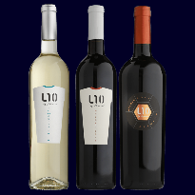

When we first heard that the Messi Foundation had linked with the Valentin Bianchi Winery in Mendoza to make 2 Malbecs and a Torrontes, it was an answer to our dreams. An authentic link to Football and an opportunity to sell one of the most popular wines in the world, an Argentinian Malbec. It is a wonderful partnership which we hope goes from strength to strength.

Bodegas Bianchi Wine Estate | Mendoza, Argentina | Football

The Wine

Born in Fasano, Italy, in 1887, Don Valentín emigrated with his family to Argentina in 1910. In 1928 he bought a small vineyard and gave birth to Bodegas Valentin Bianchi. As part of the legacy, they seek to keep alive the passion for wine and constantly exploring new horizons. Their guiding principles in wine making are to respect nature and the best viticultural and oenological practices.

Sporting Connection

Lionel Messi is arguably the best known football player in the world and regarded by many as one of the most skilful of all time. In his career he has won a record five Ballon d’Or awards, four of which he won consecutively, and a record five European Golden Shoes. Former Captain of Argentina and veteran of Barcelona FC, he has very little left to achieve in the world of football.

The Winemaker Says:

“Bodegas Bianchi and the Lio Messi Foundation are very excited to team up with Sporting Wine Club and introduce the L10 brand to the UK market. Together, we share a passion for helping others and the donation from Sporting Wine Club will contribute to improving the health and education of children with social disadvantages. We look forward to a long partnership to bring more joy and opportunities to many more children throughout the world.”

– Federico Nino

HOLLY & SIMON BELLINGHAM TURNER

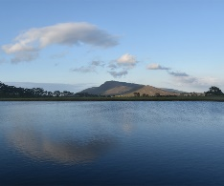
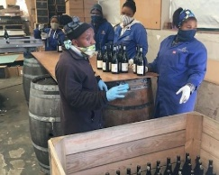
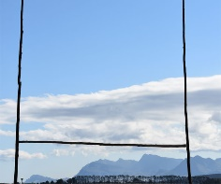
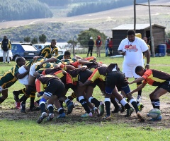
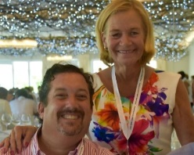

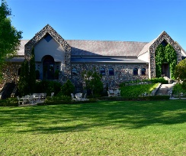
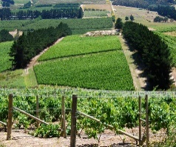
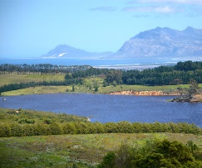

Simon and Holly Turner bought the Sumaridge Wine Estate in 2007 and we first knew them through their incredible generosity towards sporting and other charities. They stand at the heart of our company as one of our first winemaker relationships.

Sumaridge Estate Wines | Upper, Hemel-en-Aarde Valley, Hermanus, South Africa | Rugby

The Wine

Sumaridge Estates a jewel in South Africa’s crown, sitting on the crest of The Hemel en Aarde (Heaven and Earth) Valley, rising up above the Bay of Hermanus. It is a stunning place to visit. The maritime breezes ensure a coolness and minerality about the wines, in contrast to so many of their national competitors. As Estate Wines, you know that only a few hundred yards separates the grape from the press and that the true vintages are lovingly constructed.

Sporting Connection

Simon and Holly are huge sporting fans; cricket, rugby and football are just three of their passions. Their particular focus is supporting player welfare and they have put their wines and beautiful lodge to work in many a charity event and auction. Uniquely, they have also recently built a rugby pitch in their vineyard for a township rugby team, the ‘Blackbirds’, so they can now keep playing the game they love.

The Winemaker Says

“When Simon & Chris established the Sporting Wine Club, and having known them both for some time, ensuring that their members could receive Sumaridge seemed – unlike most games – a foregone conclusion! While to some people wine and sport might seem strange bedfellows, we all know that, whatever the sport, the gladiatorial battles fought on the pitch are all but forgotten in the camaraderie of the bar!”

-Simon and Holly Bellingham-Turner

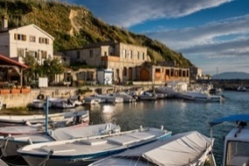
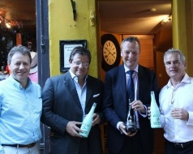
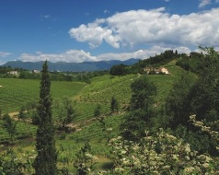
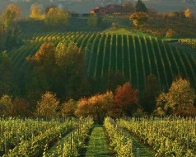
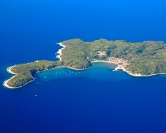
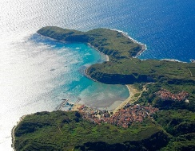
FRANCESCO COSULICH

We first met Francesco Cosulich at the 2015 Rugby World Cup watching Italy play versus France, and besides his family’s rugby prowess he is a winemaker of great quality and with a wonderful history. He and his family are deeply committed to the wine industry and are valued partners of SWC.

Collalbrigo Estate | Conegliano, Italy | Rugby

The Wine – Italy

We are thrilled to introduce a selection from Francesco’s celebrated range of wines and Proseccos produced on his Collalbrigo Estate in Northern Italy. Located on the first hill outside of Conegliano in Italy’s Veneto region, the beautiful sloping landscape has been treasured by noble Venetian families for centuries and provides the perfect environment for a winery; so much so that Francesco’s Prosecco has been commended as one of the best in the country. Francesco also brings to the table our highly exclusive – and only – sporting cocktail: Cipriani’s Bellini. Many people will be familiar with the origin of the world-famous Bellini cocktail, consisting of white peach pulp and brut sparkling wine. It was invented by Francesco’s childhood friend Guiseppe Cipriani of Harry’s Bar, Venice, in 1948 and the pair have now teamed up to produce a spectacular bottled version of this treasured cocktail which all Bellini lovers will simply adore!

Sporting Connection
The Cosulich family has an impressive sporting pedigree. Francesco and his two sons have represented Italian rugby at top levels. As a family and wine company they have also been official partners with the Italian Rugby team for the last 20 years and have contributed a huge amount to many worthwhile sporting causes.

The Winemaker Says:
“From the very moment I heard about the Sporting Wine Club, it was clear to me that this was a natural fit for myself, my family and our wine business. I immediately related to Chris and Simon’s vision for the SWC, which is built on some of the core elements I have centered my life around, such as sport, wine and friendship. My passion for sport has indeed ensured a continuous involvement of Collalbrigo’s wines with the Italian sporting environment throughout the years, ranging from sponsoring a local volleyball team when I was in my twenties to becoming the official partner of the Italian rugby team for over 20 years! An additional draw to the Sporting Wine Club was represented by the opportunity to support a fantastic cause such as ‘Life After Rugby’, which we feel very strongly about given the many examples we have seen in our own country of great young men struggling to find their path following their playing career. Giving something back is part of our sport and our nature and in the past we have been involved with the Elephant XV, and invitational team raising money for a schooling charity in Mozambique, as well as for La Colonna XV, which does an amazing fundraising job in aid of research for bone marrow diseases. We are incredibly excited about our new venture and look forward to meeting you all at the next Sporting Wine Club event.”

-Francesco Cosulich

LINDSAY MACLACHLAN
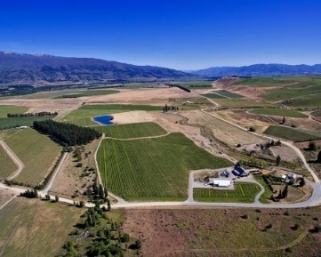
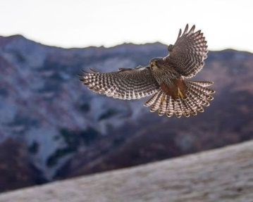
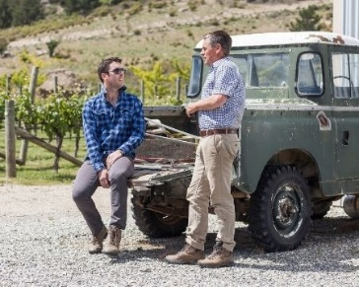
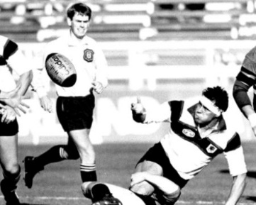
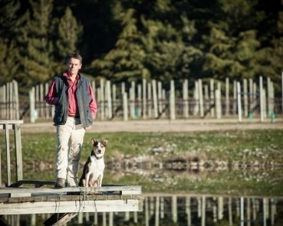

We first came to hear about Peregrine Wines in Central Otago through the International Referee Wayne Barnes, a member of SWC, who went to visit the NZ owner, Lindsay McLachlan, who refereed Internationally in the 90’s. For those of you with good memories he had control of the England v Scotland game in 1994 when England won in the last minute – Mr McLachlan awarded a last-minute penalty when the Scots transgressed – again! 15-14 was the final score and England won a famous victory.

Peregrine Wine Estate | Central Otago, New Zealand | Cricket

The Wine

Long before he blew the whistle to kick off his first test match, Lindsay had a passion for farming and winemaking. His dream was realised with Peregrine Wines, his boutique family winery which is located at the heart of New Zealand’s South Island in Central Otago. This region is the southernmost grape growing regional in the world at latitude 45 South. With vineyards nestled on north-facing slopes in breath-taking glacial carved valleys and on the shores of crystal-clear lakes, this is New Zealand’s only inland and elevated wine growing region. An environment ideal for growing Pinot Noir and aromatic white varietals (Pinot Gris and Riesling). Named in honour of New Zealand’s endemic falcon, Peregrine has gained a reputation both domestically and internationally as one of New Zealand’s iconic wine brands since the first vintage in 1998.

Sporting Connection
Lindsay McLachlan is a former international rugby referee, who controlled 8 test matches during his career which ended in 1994 as the game was about to turn professional. His sons, Fraser and Blair are both involved in the family winery and played rugby, cricket and basketball up to the provincial age group level. Whilst no longer formally involved in the game, the rugby and refereeing fraternity is a tight group and current and former players and referees regularly visit Peregrine when visiting the deep South.

The Winemaker Says

As a family we are thrilled to be in the team with the Sporting Wine Club. We share the values which stem from crafting great wine and enjoying the camaraderie in sport, and look forward to a long and enjoyable relationship with the club.

-Lindsay McLachlan

