Havant Rugby Club is pleased to be in partnership with the Sporting Wines Club https://sportingwineclub.com bringing great wines with great stories to members, supporters and event patrons.

The Sporting Wines Club is a member’s club where sport, wine and charity are celebrated as one. Founded to bring the stories behind unique winemaking sporting families to a wider sporting audience, bottling the core values of sporting communities; team spirit, good causes and of course, having a good time along the way.

HRFC’s wine list is curated from the Sporting Wines Club’s collection and served at events, over the bar (by the bottle or by the glass) and available to purchase to take home. Link To Take Away Price list

To start our partnership Simon Halliday - Founder Sporting Wine Club/Chairman European Professional Club Rugby (ex-Bath, Harlequins, and England rugby Union and an ambassador for Cardiac Risk in the Young – CRY) and the sporting wines team have put an introductory offer together.

Introductory offer: -

- Members, sponsors and supporters of HRFC can order a mixed case of 6 bottles from selected wines from the Sporting Wines collection
- a discount of 23% from the normal selling price
- 1% for each member of a full rugby squad
- Follow the link below to purchase

https://sportingwineclub.com/product/havant-upthehill-introductory-case/
and use the DISCOUNT CODE: - #upthehill23

Best wishes

Simon and the Sporting Wine Club team.

- To Join the Sporting Wines Club, see membership packages and full wine collection at: -

https://sportingwineclub.com. Don’t forget to mention Havant Rugby Club when you sign up.

- To buy wine from the Havant Rugby Club Sporting Wines Wine List, go to: -havantrfcshop.square.site
(HRFC Members use the DISCOUNT CODE: - UPTHEHILL to get your membership discount)

- Add quantity of wines you would like to order (Remember there is no minimum order)
- Club members can use code UPTHEHILL for 10% discount.
- Pay for your order.
- Your order will be ready for collection 3 working days after payment is received.

Meet the Havant RFC Sporting wines –Winemakers

SCHALK BURGER & SONS

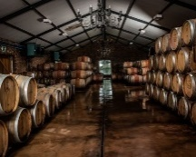
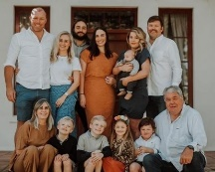
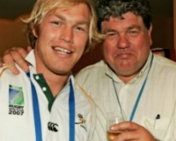

We first met Schalk Burger Senior in 2009 from an introduction by Allan Lamb the Test cricketer. As the owner of the Welbedacht Wine Estate we soon realised that here was the ultimate connection between Sport and Wine. A partnership was born and Schalk’s extensive sporting wine portfolio forms the heart of our company.

Welbedacht Wine Estate | Wellington, South Africa | Rugby

The Wine

The spectacular Welbedacht Estate lies 40 minutes north of Cape Town. Some of the oldest soil in Africa, made up of decomposed granite, provides ideal conditions for quality vines. Schalk cultivates 18 different grape varieties. Each of his wines tells a story. The entry level Meerkat range is South Africa’s most gregarious wine and unbeatable value. Among his award-winning red blends can be found the Hat Trick, Cricket Pitch, Bohemian Syrah, the Patriot and his exceptional No 6, named after the shirt both Schalk Snr and Jnr wore for their country.
Sporting Connection

Schalk Burger Sr was a formidable South Africa flanker from the 1980’s, whose son Schalk Jnr won the Rugby World Cup with the Springboks in 2007. To complement the family’s formidable rugby pedigree, Schalk hosts many charity cricket matches at his Welbedacht Oval and we are now stocking his Cricket Pitch – made from the vines grown alongside the boundary – at the Kia Oval in London, completing the sporting circle. Schalk and his sons were among our first suppliers and we are so grateful to him, Schalk Jnr, Tiaan and the whole Burger family for their support in helping us build the idea of the Sporting Wine Club. They embody the spirit of the club and have been incredibly generous and patient friends!
The Winemaker Says:

“My family and I are proud to have supported the Sporting Wine Club from its conception. They represent the values which we hold dear, combining a love of wine and sport together with friendship. We look forward to helping the Sporting Wine Club develop over the years on their exciting adventure and making many more new friends.”

-Schalk Burger Snr

LIONEL MESSI

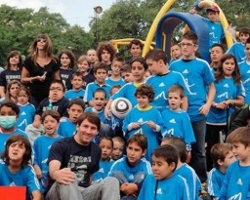
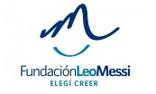
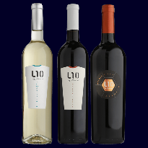
When we first heard that the Messi Foundation had linked with the Valentin Bianchi Winery in Mendoza to make 2 Malbecs and a Torrontes, it was an answer to our dreams. An authentic link to Football and an opportunity to sell one of the most popular wines in the world, an Argentinian Malbec. It is a wonderful partnership which we hope goes from strength to strength.

Bodegas Bianchi Wine Estate | Mendoza, Argentina | Football

The Wine

Born in Fasano, Italy, in 1887, Don Valentín emigrated with his family to Argentina in 1910. In 1928 he bought a small vineyard and gave birth to Bodegas Valentin Bianchi. As part of the legacy, they seek to keep alive the passion for wine and constantly exploring new horizons. Their guiding principles in wine making are to respect nature and the best viticultural and oenological practices.

Sporting Connection

Lionel Messi is arguably the best known football player in the world and regarded by many as one of the most skilful of all time. In his career he has won a record five Ballon d’Or awards, four of which he won consecutively, and a record five European Golden Shoes. Former Captain of Argentina and veteran of Barcelona FC, he has very little left to achieve in the world of football.

The Winemaker Says:

“Bodegas Bianchi and the Lio Messi Foundation are very excited to team up with Sporting Wine Club and introduce the L10 brand to the UK market. Together, we share a passion for helping others and the donation from Sporting Wine Club will contribute to improving the health and education of children with social disadvantages. We look forward to a long partnership to bring more joy and opportunities to many more children throughout the world.”

– Federico Nino

HOLLY & SIMON BELLINGHAM TURNER
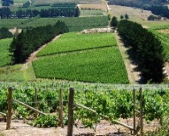
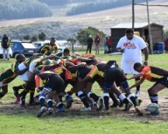
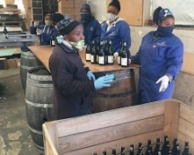
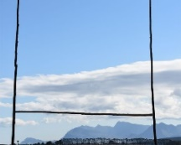
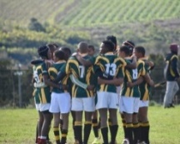
Simon and Holly Turner bought the Sumaridge Wine Estate in 2007 and we first knew them through their incredible generosity towards sporting and other charities. They stand at the heart of our company as one of our first winemaker relationships.

Sumaridge Estate Wines | Upper, Hemel-en-Aarde Valley, Hermanus, South Africa | Rugby

The Wine

Sumaridge Estates a jewel in South Africa’s crown, sitting on the crest of The Hemel en Aarde (Heaven and Earth) Valley, rising up above the Bay of Hermanus. It is a stunning place to visit. The maritime breezes ensure a coolness and minerality about the wines, in contrast to so many of their national competitors. As Estate Wines, you know that only a few hundred yards separates the grape from the press and that the true vintages are lovingly constructed.

Sporting Connection

Simon and Holly are huge sporting fans; cricket, rugby and football are just three of their passions. Their particular focus is supporting player welfare and they have put their wines and beautiful lodge to work in many a charity event and auction. Uniquely, they have also recently built a rugby pitch in their vineyard for a township rugby team, the ‘Blackbirds’, so they can now keep playing the game they love.

The Winemaker Says

“When Simon & Chris established the Sporting Wine Club, and having known them both for some time, ensuring that their members could receive Sumaridge seemed – unlike most games – a foregone conclusion! While to some people wine and sport might seem strange bedfellows, we all know that, whatever the sport, the gladiatorial battles fought on the pitch are all but forgotten in the camaraderie of the bar!”

-Simon and Holly Bellingham-Turner

FRANCESCO COSULICH
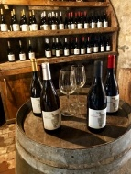
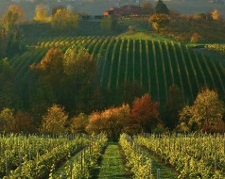
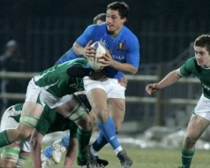
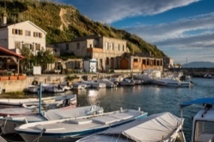
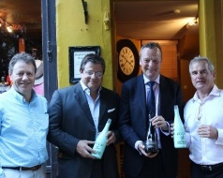
We first met Francesco Cosulich at the 2015 Rugby World Cup watching Italy play versus France, and besides his family’s rugby prowess he is a winemaker of great quality and with a wonderful history. He and his family are deeply committed to the wine industry and are valued partners of SWC.

Collalbrigo Estate | Conegliano, Italy | Rugby

The Wine – Italy

We are thrilled to introduce a selection from Francesco’s celebrated range of wines and Proseccos produced on his Collalbrigo Estate in Northern Italy. Located on the first hill outside of Conegliano in Italy’s Veneto region, the beautiful sloping landscape has been treasured by noble Venetian families for centuries and provides the perfect environment for a winery; so much so that Francesco’s Prosecco has been commended as one of the best in the country. Francesco also brings to the table our highly exclusive – and only – sporting cocktail: Cipriani’s Bellini. Many people will be familiar with the origin of the world-famous Bellini cocktail, consisting of white peach pulp and brut sparkling wine. It was invented by Francesco’s childhood friend Guiseppe Cipriani of Harry’s Bar, Venice, in 1948 and the pair have now teamed up to produce a spectacular bottled version of this treasured cocktail which all Bellini lovers will simply adore!

Sporting Connection
The Cosulich family has an impressive sporting pedigree. Francesco and his two sons have represented Italian rugby at top levels. As a family and wine company they have also been official partners with the Italian Rugby team for the last 20 years and have contributed a huge amount to many worthwhile sporting causes.

The Winemaker Says:
“From the very moment I heard about the Sporting Wine Club, it was clear to me that this was a natural fit for myself, my family and our wine business. I immediately related to Chris and Simon’s vision for the SWC, which is built on some of the core elements I have centered my life around, such as sport, wine and friendship. My passion for sport has indeed ensured a continuous involvement of Collalbrigo’s wines with the Italian sporting environment throughout the years, ranging from sponsoring a local volleyball team when I was in my twenties to becoming the official partner of the Italian rugby team for over 20 years! An additional draw to the Sporting Wine Club was represented by the opportunity to support a fantastic cause such as ‘Life After Rugby’, which we feel very strongly about given the many examples we have seen in our own country of great young men struggling to find their path following their playing career. Giving something back is part of our sport and our nature and in the past we have been involved with the Elephant XV, and invitational team raising money for a schooling charity in Mozambique, as well as for La Colonna XV, which does an amazing fundraising job in aid of research for bone marrow diseases. We are incredibly excited about our new venture and look forward to meeting you all at the next Sporting Wine Club event.”

-Francesco Cosulich

LINDSAY MACLACHLAN
