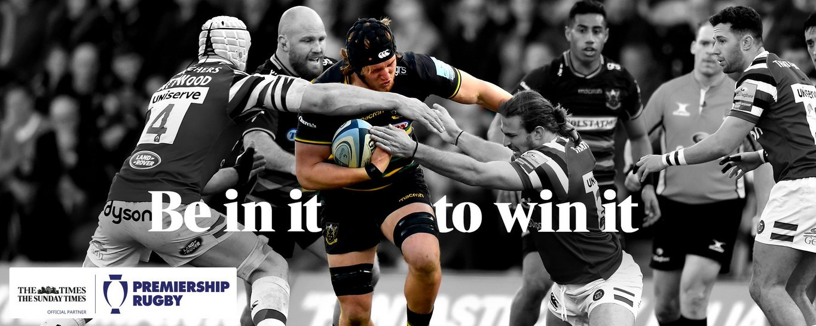
The HRFC “Up The Hill” Lottery
The “Up The Hill” Lottery is a simple but exciting way of fundraising for Havant Rugby Club (“Havant Rugby Football Club Ltd.”). It is a way for members and supporters of the club to help raise valuable funds for the development of the club, whilst at the same time being in with a chance of winning attractive cash prizes during the year. With 50% of the income generated being paid out in cash prizes the more people who participate the “Up The Hill” Lottery the higher the prize money can be. As an example, if we reach 500 participants the total cash prizes each calendar year becomes £15,000 making the 1st prize in the Grand Annual Draw in excess of £4,000, the more participants the bigger prizes or more frequent prize draws could be!

Monies raised each year will be put towards Fixtures and Fittings. The club will regularly communicate to participants, the projects that the funds will be used for and, subsequently, how it was spent.

We invite you to give yourself a chance to win cash prizes and at the same time support our fantastic Rugby Club.

To get started, purchase your numbers and set up your direct debit, please log into GMS through the club website via this link: https://havantrfc.rfu.club/products. Then, just like any other online purchase, if you already have a GMS account log-in to it, if you do not have a GMS account then just register and create one (you do not have to be a member of the club to use GMS to purchase your numbers). Once you are logged in, you will be able to purchase the HRFC Lottery Product and will be allocated a number in the draw.

If you are not sure about using GMS then please complete an application form and send it to Alan Newton, Paddy Watson or Catherine Campkin at the club and they will process the forms for you. Application forms are available on the website or at the bar.

THE “Up The Hill” LOTTERY RULES
- The lottery will be called the “Up The Hill” Lottery and is registered with Havant Borough Council under the Gambling Commission rules. Registration Number is 1046

- Participation in the “Up The Hill” Lottery is open to all members and supporters of HRFC.

- The cost of membership will be £5 per lottery number per month, payments being made by Direct Debit through the GMS Payments System. Members will only be entered into the draw when their DD payment has been cleared for that month.
  - When buying a monthly subscription member will need to enter their DD details (if they do not have one set up on GMS) before continuing to pay. This ensures they have a DD set up for future payments.
  - For the first payment there will be the option to pay by card or continue and pay by direct debit.
  - If a monthly subscription membership is purchased 10 days before the end of the month then the member will be charged for 2 months
  - With monthly subscriptions there is no instalment plan, an order will be created 6 days before the payment is due e.g. 1st February payment = order created on 26th January.
  - Members will receive an email to inform them a payment will be taken.

- The purpose of the “Up The Hill” Lottery is to receive funds from participants and to re-distribute these funds between the holders of winning draw numbers and contribute to HRFC investment projects.

- The spilt will be 50% to prizes (“the Prize Fund”) and 50% to HRFC investment project funding (“the Project Funds”) rounded to the nearest pound in favour of the Project Funds. The Project Funds will be retained in a development fund and will cover specific infrastructure projects for fixtures and fittings.

- Each financial year, the club management board will identify the major projects to be undertaken in that financial year. Some projects may extend over two or more financial years.

- Participants may hold multiple numbers.

- Numbers are not transferable.

- New participants will be allocated number(s) from the pool of unallocated numbers. This will normally be the lowest available number first in an effort to maintain a contiguous range of numbers for each draw. Prizes will be awarded by the random selection of numbers held by eligible participants at the time of the draw and will be paid by bank transfer.

- On cessation of participation in the “Up The Hill” Lottery, (failure to pay for a number for 2 consecutive months) any numbers for which payments were made, will be returned to the pool of unallocated numbers.

- Winners will be announced on the Havant RFC website and in the regular club Newsletter.

- Whenever possible draws will be made at lunches before the First XV home games during the season or at any public event, out of season, to include all participants who have paid their monthly payment on the first day of that month. Where there is no suitable club event the draw will be made at the club in front of independent witnesses.

- Monthly Draws will be made January to November inclusive.

- The Monthly Draw prizes (11 times p.a.) will each consist of 1 × £100 and 1 × £50. The number of these prizes will be increased as the total membership increases.

- Two Quarterly Draws will be made each year, in addition to the monthly draws, they will be made in March and September. The Quarterly Draw prizes (2 times p.a.) will each consist of 1 × £1000. Participants will be entered into the quarterly draws if they have purchased a number (at least one a month), 5 times in the previous 6 months.

- In each calendar year after taking into account the payment of all the Monthly Draw prizes and all the Quarterly Draw prizes for that year the balance of the Prize Fund for that year will be applied towards the Grand Annual Draw (“the Grand Annual Draw Fund”). The Grand Annual Draw will be made in December (it will be the only draw in December) and will (if at all possible) be held at Havant RFC’s annual Christmas pre-match lunch. The cost of the lunch will be refunded for any winners attending in addition to their prize. Participants will be entered for Grand Annual Draw if they have purchased a lottery number (at least one a month), 9 times in the previous 12 months.

- The Grand Annual Draw Fund will be allocated in the following proportions:

Prize Money Distribution | Example if 500 Participants
1st drawn number : 40% | £4,140
2nd drawn number : 20% | £2,070
3rd drawn number : 20% | £2,070
4th drawn number : 10% | £1,035
5th drawn number : 5% | £517.50
6th drawn number : 5% | £517.50

- For any draw where more than one prize is available, then:

  - Any individual may only win one prize; and

  - The prizes will be drawn in descending value order (i.e. the biggest prize first).

- Should the participation of the “Up The Hill” Lottery fall below 150 persons the “Up The Hill” Lottery viability will be reviewed by the management board and on their decision may be wound up. In this situation, any payments received by the “Up The Hill” Lottery after the last draw and before the date of cessation of the “Up The Hill” Lottery will be refunded.

- With the “Up The Hill” Lottery being a constituent part of Havant RFC Social Club Limited, the incumbent Directors of Havant RFC Social Club Limited will have sole responsibility for the implementation of these rules and the overall management of the “Up The Hill” Lottery. In any instances requiring adjudication their decision will be final.

- Havant RFC Social Club Limited reserves the right to change these rules, subject to giving a minimum of two (2) months’ notice to all current participants.

